EXERCISE 1:

**WHAT IS QUALITY?**

***(Activities)***

• Connect the words to their appropriate definition :

1-Performance 2-Features

1. Reliability
2. Technical durability 5-Serviceability
3. Aesthetics
4. Perceived quality 8-Value for money

A-Additional parts or characteristics that the product offers.

B-How well the product continues to perform without breakdowns.

C-How well the product performs its main function.

D-How long the product lasts before becoming technically obsolete out of date.

E-The look and feel of the product.

F-The customer’s judgment of the product’s level of quality. G-How easy the product is to service maintain and repair.

H-What the product does in relation to the price paid for it.

1-C, 2-A, 3-B, 4-D, 5-G, 6-E, 7-F, 8-H

EXERCISE 2:

* Match the sentences (1-8) with the appropriate words ( a-h ) :

1. We guarantee five years or 100,000 Kilometers of trouble-free motoring.
2. 2- No other brand gives better performance in this price category.

3- It only requires servicing every 25,000 kilometers. 4- It has beautiful lines.

5- It has heated seats for the driver and the passenger. 6- It has the latest engine technology.

1. It goes from zero to 100 kilometers per hour in four seconds.
2. Customer surveys give us top marks for quality compared to other leading car makes.
   1. Performance 7
   2. Features 5
   3. Reliability 1
   4. Technical durability 6
   5. Serviceability 3
   6. Aesthetics 4
   7. Perceived quality 8
   8. Value for money 2

EXERCISE 3:

* Find the 6 words hidden using the definitions below :

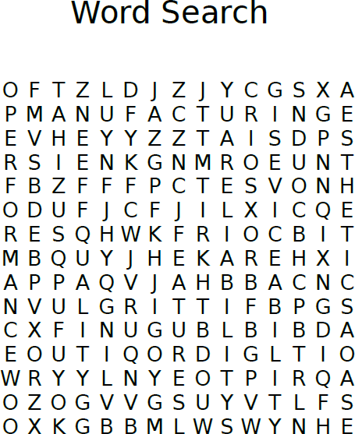

1. How easy the product is to service maintain and repair
2. How well the product performs its main function
3. Additional parts or characteristics that the product offers
4. How well the product continues to perform without breakdowns
5. How good or bad something is.
6. The industry or business of making products especially with machines in factories

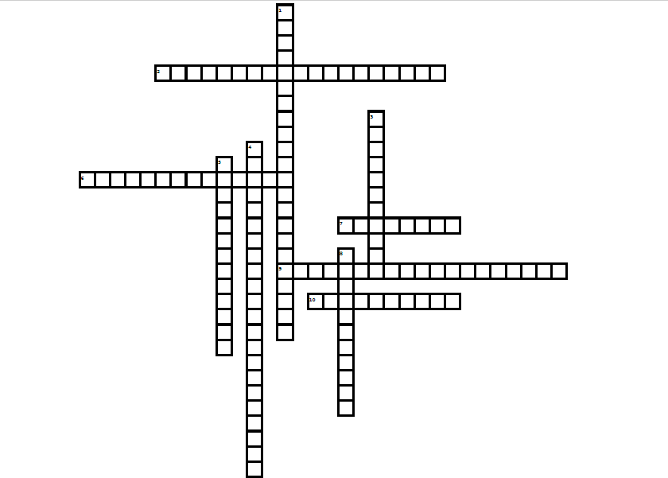

EXERCISE 4:

* Fill the Crossword Puzzle:

**Down:**

* 1. describes a management approach to long-term success through customer satisfaction Total Quality Management

1. the ability of a product, service, or process to meet its design specifications Conformance
2. the process of improving the quality of a product by trying to make it exactly as it was designed Elimination of variation
3. what the product does in relation to the price paid for it Value for money

8. the ability of an organization to bring about dynamic quality perspective Consistency

**Across:**

2. time product lasts before becoming technically obsolete out of date Technical Durability

1. comparison of perceived expectations of a service with perceived performance Service Quality
2. characteristics that the product offers Features
3. is a process for empowering members of an organization to make decisions and to solve problems appropriate to their levels in the organization Employee involvment
4. the look and feel of the product Aesthetics